Selenium Automation Programs

Selenium Code 1 – Flipkart Login
from selenium import webdriver
from selenium.webdriver.common.by import By import time
driver = webdriver.Edge() driver.get("https://www.flipkart.com/login?ret=/") time.sleep(3)
inputs = driver.find_elements(By.TAG_NAME, "input") phone = inputs[7]
number = “9790194728"
phone.send_keys(number) time.sleep(1)
buttons = driver.find_elements(By.TAG_NAME, "button")
print("Number of buttons:", len(buttons))

for i in range(len(buttons)): print(i, "=>", buttons[i].text)
for button in buttons:
if button.text.strip() == "Continue": button.click()
print("Continue clicked")
break time.sleep(3)
input("Enter OTP manually in the browser, then press Enter here...")
print("OTP step completed")
input("Press Enter to close the browser...") driver.quit()
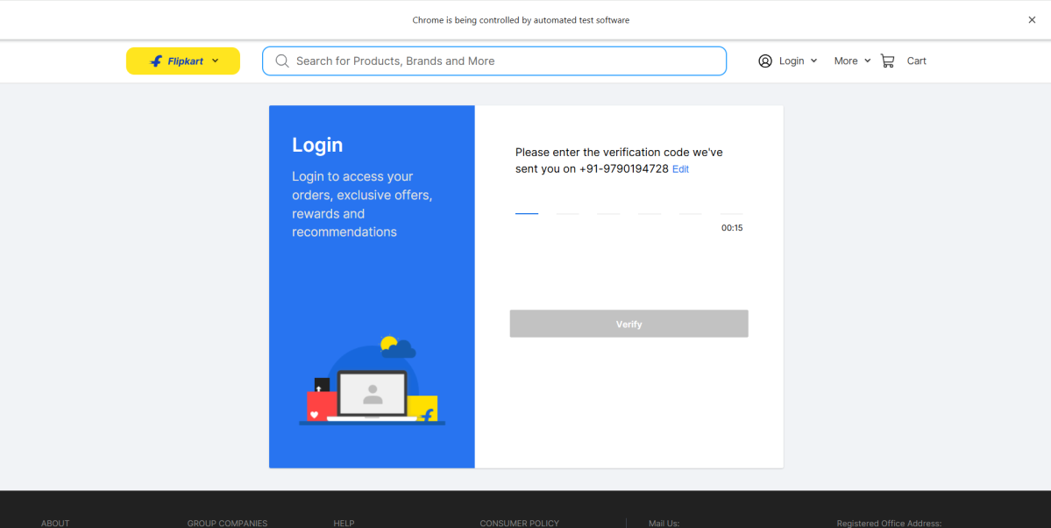

Selenium Code 2 – SauceDemo Product Login

from selenium import webdriver
from selenium.webdriver.common.by import By
from selenium.webdriver.support.ui import WebDriverWait
from selenium.webdriver.support import expected_conditions as EC import time
driver = webdriver.Chrome() driver.get("https://saucedemo.com")
username = driver.find_element(By.ID, "user-name") password = driver.find_element(By.NAME, "password") login = driver.find_element(By.ID, "login-button") username.send_keys("standard_user") password.send_keys("secret_sauce")
login.click()
print("\n--- Logging in... ---") try:
WebDriverWait(driver, 10).until( EC.presence_of_element_located((By.CLASS_NAME, "inventory_list"))
)
products = driver.find_elements(By.CLASS_NAME, "inventory_item_name") print(f"\nSuccessfully logged in! Found {len(products)} products on the
screen:\n")
for index, item in enumerate(products, start=1): print(f"{index}. {item.text}")

time.sleep(3) finally:
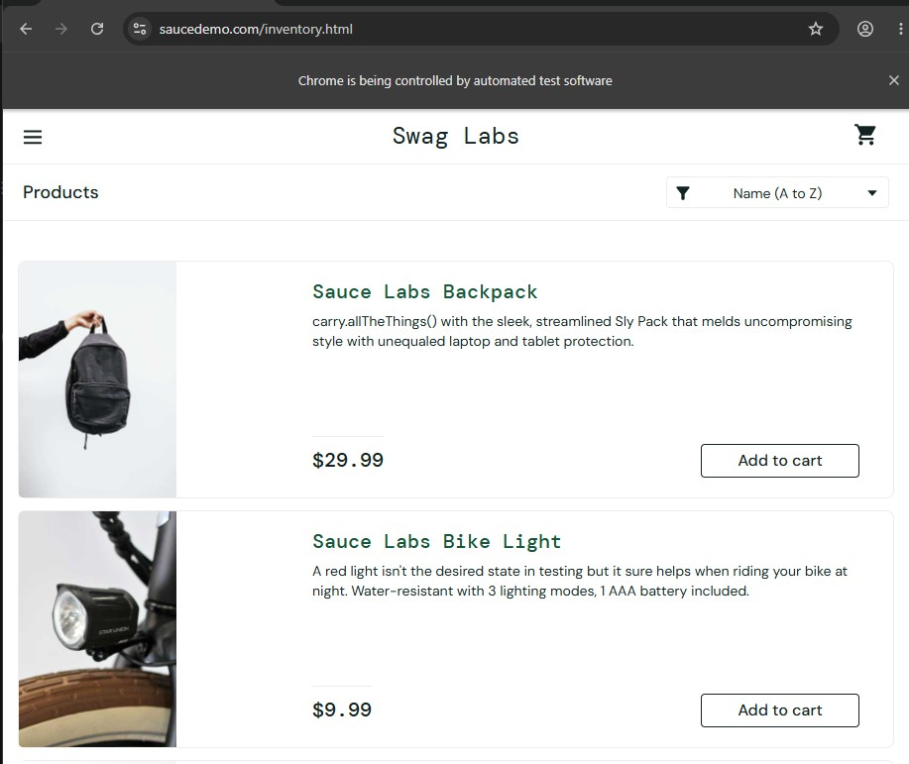
driver.quit()

Selenium Code 3 – Google Search for Actor Suriya
from selenium import webdriver
from selenium.webdriver.common.by import By from selenium.webdriver.common.keys import Keys
from selenium.webdriver.chrome.options import Options from selenium.webdriver.support.ui import WebDriverWait
from selenium.webdriver.support import expected_conditions as EC

chrome_options = Options() chrome_options.add_experimental_option("detach", True)

chrome_options.add_argument("--guest")
chrome_options.add_argument("--disable-blink-features=AutomationControlled") driver = webdriver.Chrome(options=chrome_options) driver.get("https://google.com")
search_box = driver.find_element(By.NAME, "q") search_box.send_keys("actor suriya" + Keys.ENTER) WebDriverWait(driver, 10).until(
EC.presence_of_element_located((By.XPATH, "//div[@role='listitem']//img |
//img[@data-deferred='1']"))
)
print("True") driver.quit()
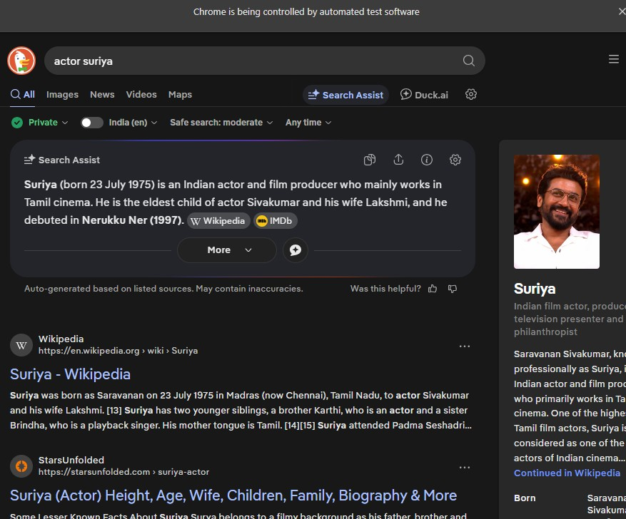

Selenium Code 4 – UserID and Password Login
from selenium import webdriver
from selenium.webdriver.common.by import By driver = webdriver.Chrome() driver.get("https://saucedemo.com/")
username = driver.find_element(By.ID, "user-name")
password = driver.find_element(By.NAME, "password") login = driver.find_element(By.ID, "login-button") username.send_keys("standard_user") password.send_keys("secret_sauce") print(username.get_attribute("placeholder")) print(login.is_enabled()) print(username.is_displayed())
login.click()

